UBUNTU COMMANDS

OPERATING SYSTEM LABS



ASSIGNMENT # 01

Submitted By

BASHARAT HUSSAIN

(17P6102)

Submitted To

MR. MUHAMMAD ABDULLAH

(COMPUTER INSTRUCTOR)

DEPARTMENT OF COMPUTER SCIENCE
FAST NATIONAL UNIVERSITY OF COMPUTER AND
EMERGING SCIENCE, PESHAWAR

Session 2017-2021

‘usermod’ command :
In Linux operating systems the command ‘usermod‘ is used to modify or change any attributes of a already created user account via command line. The command ‘usermod‘ is similar to that ‘useradd‘ or ‘adduser‘ but the login granted to an existing user.
After creating user accounts, in some scenarios where we need to change the attributes of an existing user such as, change user’s home directory, login name, login shell, password expiry date, etc, where in such case ‘usermod’ command is used.
When we execute ‘usermod‘ command in terminal, the following files are used and affected.
- /etc/passwd – User account information.
- /etc/shadow – Secure account information.
- /etc/group – Group account information.
- /etc/gshadow – Secure group account information.
- /etc/login.defs – Shadow password suite configuration..

Basic syntax of command is:

usermod [options] username

Requirements
- We must have existing user accounts to execute usermod command.
- Only superuser (root) is allowed to execute usermod command.
- The usermod command can be executed on any Linux distribution.
- Must have basic knowledge of usermod command with options

Options of Usermod
The ‘usermod‘ command is simple to use with lots of options to make changes to an existing user. Let us see how to use usermod command by modifying some existing users in Linux box with the help of following options.
- -c = We can add comment field for the useraccount.
- -d = To modify the directory for any existing user account.
- -e = Using this option we can make the account expiry in specific period.
- -g = Change the primary group for a User.
- -G = To add a supplementary groups.
- -a = To add anyone of the group to a secondary group.
- -l = To change the login name from tecmint to tecmint_admin.
- -L = To lock the user account. This will lock the password so we can’t use the account.
- -m = moving the contents of the home directory from existing home dir to new dir.
- -p = To Use un-encrypted password for the new password. (NOT Secured).
- -s = Create a Specified shell for new accounts.
- -u = Used to Assigned UID for the user account between 0 to 999.
- -U = To unlock the user accounts. This will remove the password lock and allow us to use the user account.

1. Adding Information to User Account
The ‘-c‘ option is used to set a brief comment (information) about the user account. For example, let’s add information on ‘hussain1‘ user, using the following command.
sudo usermod -c "this is basharat" hussain1

After adding information on user, the same comment can be viewed in /etc/passwd file.

# grep -E --color 'hussain1' /etc/passwd

hussain1:x:1002:1002:this is basharat:/home/hussain1:/bin/sh

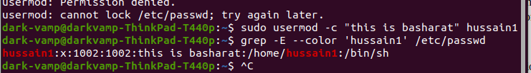

2. Change User Home Directory
In the above step we can see that our home directory is under /home/hussain1/, If we need to change it to some other directory we can change it using -d option with usermod command.
For example, I want to change our home directory to /var/www/, but before changing, let’s check the current home directory of a user, using the following command.
# grep -E --color '/home/hussain1' /etc/passwd

hussain1:x:1002:1002:This is basharat:/home/tecmint:/bin/sh

Now, change home directory from /home/hussain to /var/www/ and confirm the home director after changing.

# usermod -d /var/www/ hussain1
# grep -E --color '/var/www/' /etc/passwd

hussain1:x:1002:1002:This is hussain1:/var/www:/bin/sh

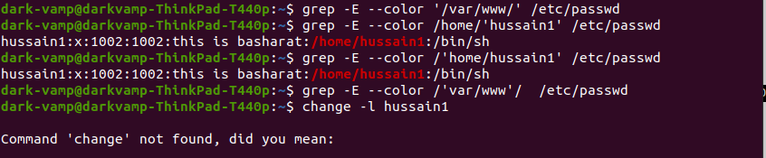

3. Set User Account Expiry Date
The option ‘-e‘ is used to set expiry date on a user account with the date format YYYY-MM-DD. Before, setting up an expiry date on a user, let’s first check the current account expiry status using the ‘chage‘ (change user password expiry information) command.

# chage -l hussain1

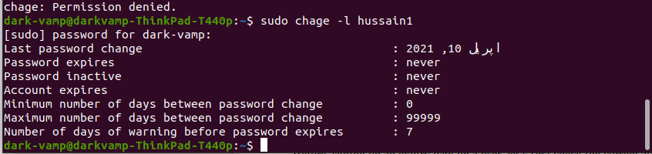

The expiry status of a ‘hussain1‘ user is Dec 1 2014, let’s change it to Nov 1 2014 using ‘usermod -e‘ option and confirm the expiry date with ‘chage‘ command.

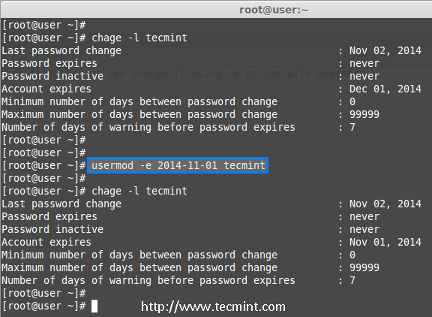

4. Change User Primary Group
To set or change a user primary group, we use option ‘-g‘ with usermod command. Before, changing user primary group, first make sure to check the current group for the user hussain1.

# id hussain1

uid=1002(hussain1) gid=1002(hussain1) groups=1002(hussain1)

Now, set the babin group as a primary group to user hussain1 and confirm the changes.

# usermod -g babin hussain1
# id hussain1

uid=501(hussain1) gid=502(babin) groups=502(hussain1)

5. Adding Group to an Existing User
If you want to add a new group called ‘hussain1_test0‘ to ‘hussain1‘ user, you can use option ‘-G‘ with usermod command as shown below.

# usermod -G hussain1_test0 hussain1
# id hussain1

6. Change User Login Name
To change any existing user login name, we can use ‘-l‘ (new login) option. In the example below, we changing login name hussain1 to hussain1_admin. So the username hussain1 has been renamed with the new name hussain1_admin.

# usermod -l hussain1_admin husssain1

Now check for the tecmint user, It will not be present because we have changed it to tecmint_admin.

# id hussain1
Check for the tecmint_admin account it will be there with same UID and with existing group what we have added before.

# id hussain_admin

7. Lock User Account
To Lock any system user account, we can use ‘-L‘ (lock) option, After the account is locked we can’t login by using the password and you will see a ! added before the encrypted password in /etc/shadow file, means password disabled.

# usermod -L babin

Check for the locked account.

# grep -E --color 'babin' cat /etc/shadow

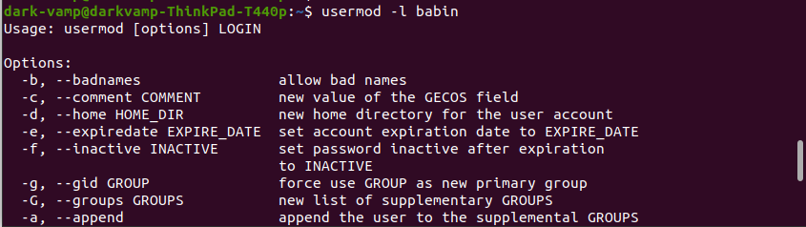

8. Unlock User Account
The ‘-U‘ option is used to unlock any locked user, this will remove the ! before the encrypted password.

# grep -E --color 'babin' /etc/shadow
# usermod -U babin

Verify the user after unlock.

# grep -E --color 'babin' /etc/shadow

9. Change User Shell
The user login shell can be changed or defined during user creation with useradd command or changed with ‘usermod‘ command using option ‘-s‘ (shell). For example, the user ‘babin‘ has the /bin/bash shell by default, now I want to change it to /bin/sh.

# grep -E --color 'babin' /etc/passwd
# usermod -s /bin/sh babin

After changing user shell, verify the user shell using the following command.
# grep -E --color 'babin' /etc/passwd

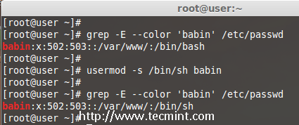

10. Change User ID (UID)
In the example below, you can see that my user account ‘babin‘ holds the UID of 502, now I want to change it to 888 as my UID. We can assign UID between 0 to 999.
# grep -E --color 'babin' /etc/passwd
OR
# id babin
Now, let’s change the UID for user babin using ‘-u‘ (uid) option and verify the changes.

# usermod -u 888 babin
# id babin

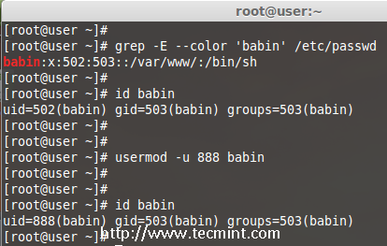

THANKS

